# Deployment Document

## Restriction Of Dataset Sharing During Project Assign(ACL)

## Problem Statement: Restriction of particular cost related data set sharing during project assign.

**Proposed Solution:** Write the ACL for access restrict

1. “CostDocACL” ACL is created.
2. “Read” Access is restricted for particular supplier’s group

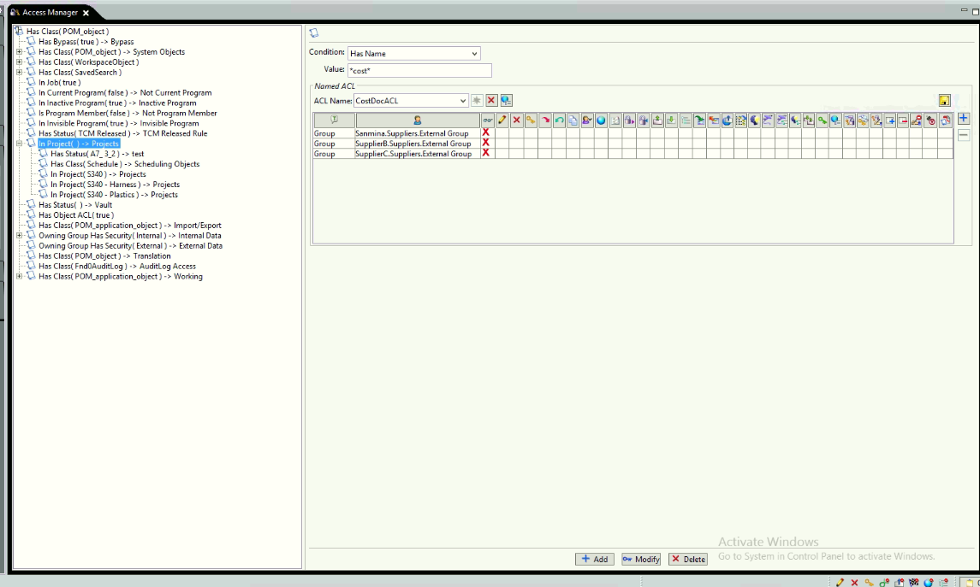

**Steps** : Example 1

1. Login to Teamcenter with dba group user. And create any type of item

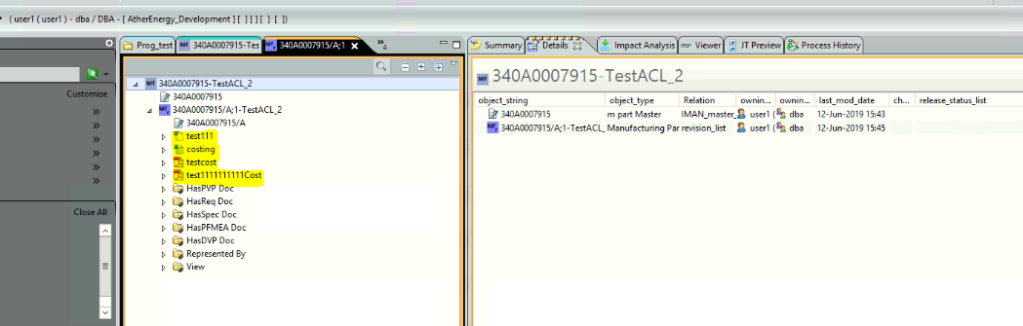

1. Assign project to that particular item

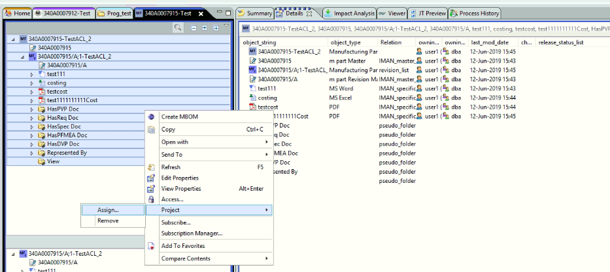

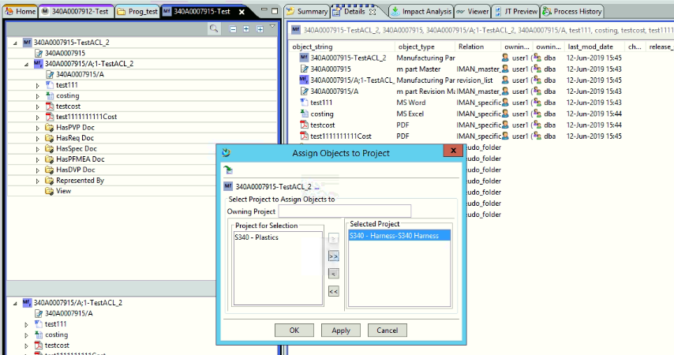

1. Login with supplier ID

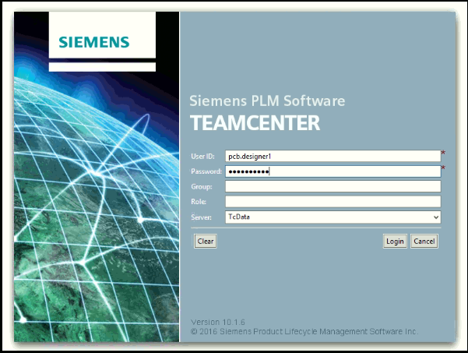

1. Check group should be supplier

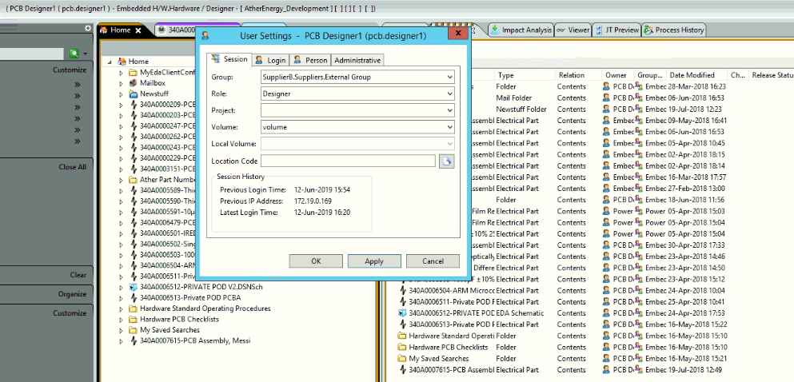

1. Search and open item

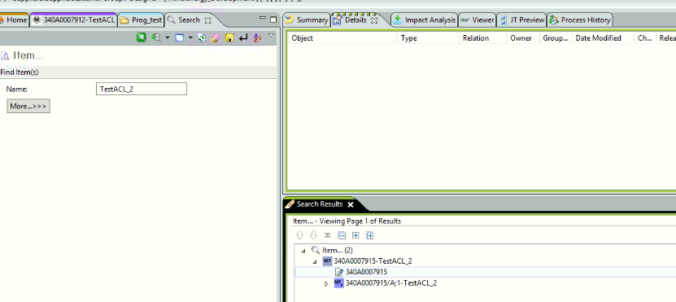

**Result:** Cost related datasets are hidden from supplier user

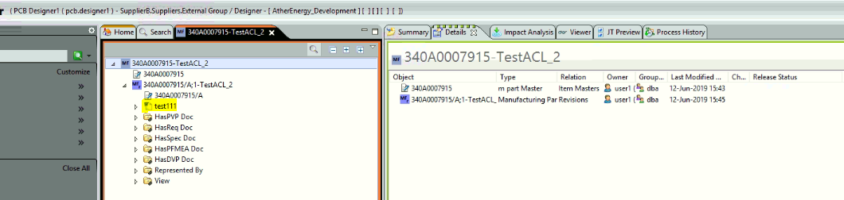

Example 2:

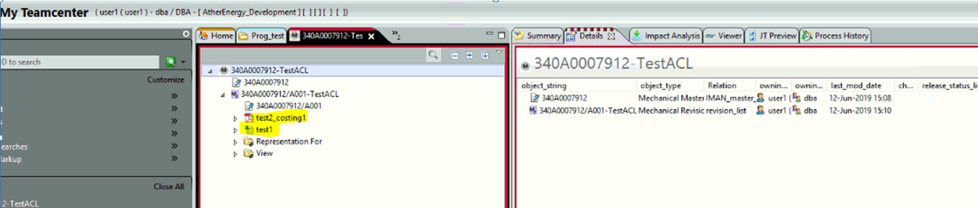

Result :

